**Sprint 4 Plan**

**UCSC Academic Planner, May 24th 2023**

**Goal**

* Generate a 4-year planner based on major, customize planner, and get user authentication working.

**User Stories**

* 3.1 I am someone interested in UCSC and want to see all majors from each department. [3]
  + Finish web scraping all departments and majors from webpage
  + Web scrape major requirements
* 3.2 I am a UCSC student and I want to see a 4-year planner for my major. [5] (from backlog)
  + Generate planner for major
  + Create table for the planner in UI
* 3.3 I have a schedule that I made already, but want to make changes/possibly add classes. [3] (from backlog)
  + Drag and drop to add classes in created planner
  + Remove classes from planner
* 3.4 I am a UCSC student and I want to save my 4-year planner, so I can review it again at a later time. [8]
  + Add user authentication
  + Save generated planner in database

**Team Roles**

Betros Abraha (Product Owner)

Jin Lee

Brandan Fong

Sean Carlyle

Michelle Hernandez (Scrum Master)

**Task Assignment**

Betros Abraha: User story 3.4

Jin Lee: User story 3.2

Brandan Fong: User story 3.3

Sean Carlyle: User story 3.1

Michelle Hernandez: User story 3.2

**Planned Burnup Chart**

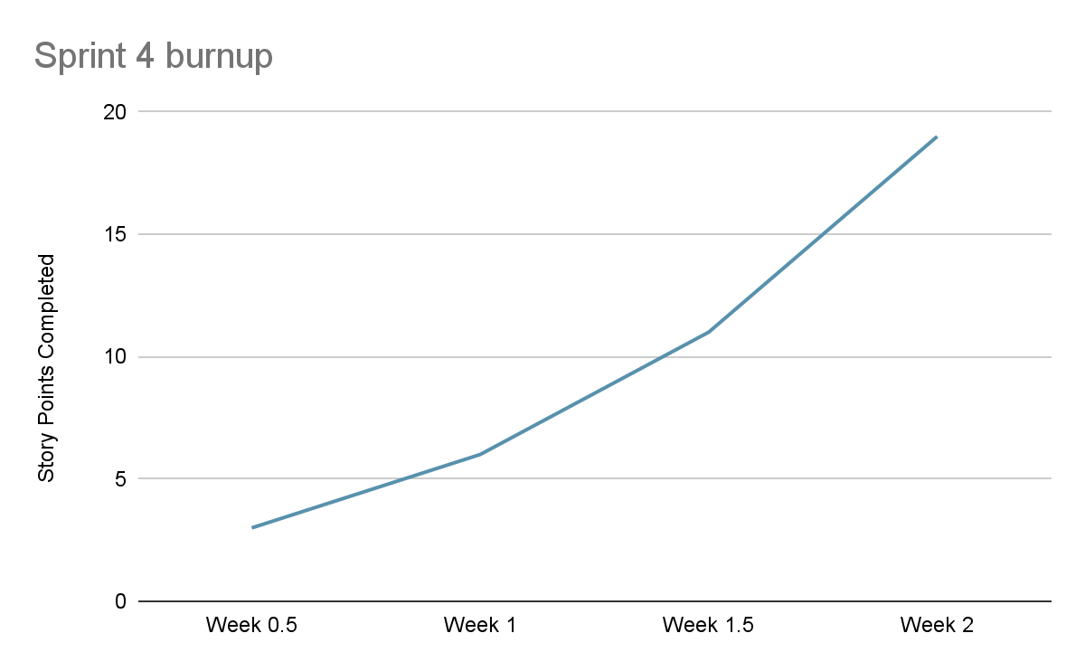

**Initial Scrum Board**

| **User stories** | **Tasks not started** | **Tasks in progress** | **Tasks completed** |
| --- | --- | --- | --- |
| * 3.1I am someone interested in UCSC and want to see all majors from each department. [3] * 3.2 I am a UCSC student and I want to see a 4-year planner for my major. [5] (from backlog) * 3.3 I have a schedule that I made already, but want to make changes/possibly add classes. [3] (from backlog) * 3.4 I am a UCSC student and I want to save my 4-year planner, so I can review it again at a later time. [8] | * Finish adding all departments and majors from webpage * Generate planner for major * Create table for the planner in UI * Drag and drop to add classes in created planner * Remove classes from planner * Add user authentication * Save generated planner in database |  |  |

**Scrum Times**

Meeting MF 9:05am, T 8 pm

TA meeting: W 3:55pm